**Experiment Number:** ***10*** **Date:** 24/03/2011

**Single Phase Inverter using IGBT**

**Aim:**

To simulate the circuit of a single phase inverter using IGBTs and verify its operation using MATLAB and Simulink.

**Components Required:**

The following components are required from the Simulink block-sets:

|  |  |  |  |
| --- | --- | --- | --- |
| **S.No.** | **Component** | **No.** | **Specification** |
| 1. | DC Voltage Source | 1 | 100V |
| 2. | IGBT | 4 | - |
| 3. | Series RL Load | 1 | - |
| 4. | Measuring Scope | 1 | - |
| 5. | Pulse Generator | 2 | - |

**Description:**

The main objective of static power converters is to produce an ac output waveform from a dc power supply. These are the types of waveforms required in adjustable speed drives (ASDs), uninterruptible power supplies (UPS), static var compensators, active filters, flexible ac transmission systems (FACTS), and voltage compensators. For sinusoidal ac outputs, the magnitude, frequency, and phase should be controllable. According to the type of ac output waveform, these topologies can be considered as voltage source inverters (VSIs), where the independently controlled ac output is a voltage waveform, or as current source inverters(CSIs), where the independently controlled ac output is a current waveform.

Single-phase voltage source inverters (VSIs) can be found as half-bridge and full-bridge topologies. Although the power range they cover is the low one, they are widely used in power supplies, single-phase UPSs, and currently to form elaborate high-power static power topologies, such as for instance, the multicell configurations.

**Circuit Diagram:**

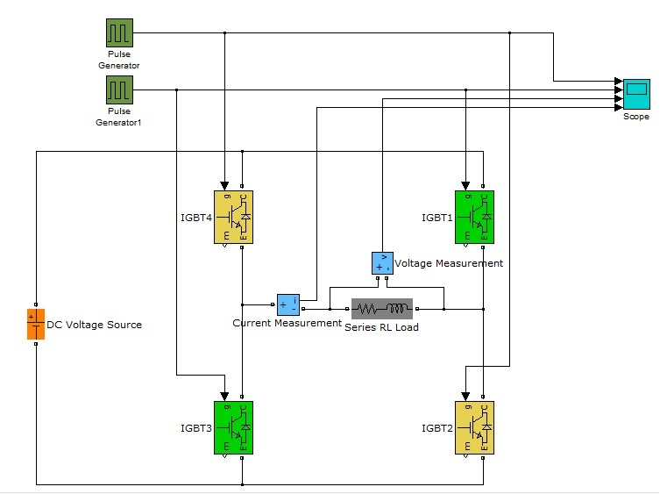

**Working:**

During the first half cycle, IGBT2 and IGBT4 are triggered with a gate pulse. During the next half cycle, gate pulses to IGBT2 and IGBT4 are removed and IGBT1 and IGBT3 are triggered. Thus the voltage waveform available at the load is a square wave. Since this type of triggering does not involve any kind of modulation, it is a simple square wave inverter. The output contains many harmonics and these can be reduced using various techniques like pulse width modulation, sinusoidal pulse width modulation and selective harmonic elimination.

**Output Waveforms:**

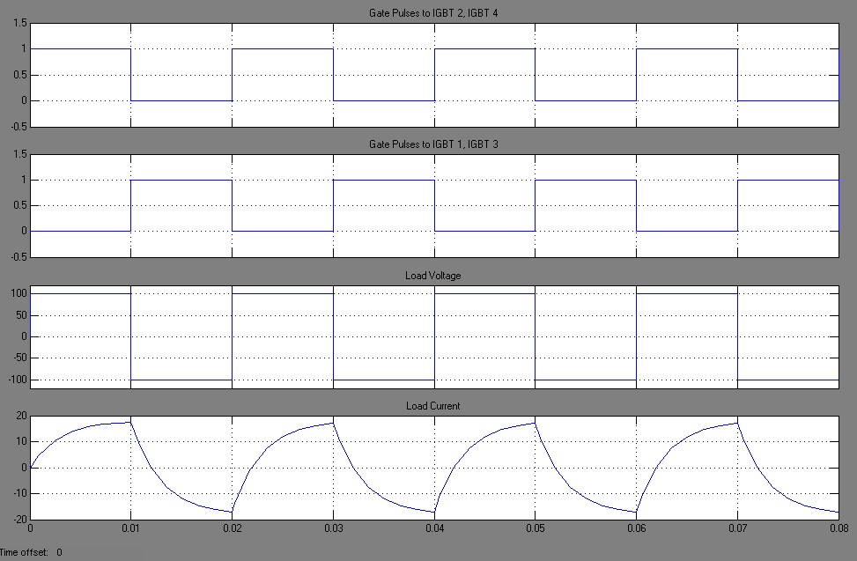The various waveforms obtained after the simulation of the circuit are shown below. They include gate pulses to IGBT2 and IGBT4, IGBT1 and IGBT3 and the load current and load voltages over four cycles. Frequency of the output is 50 Hz.

The current has a non-linear variation because of the presence of R-L load. These waveforms hence portray the operation of the single phase square-wave inverter.

**Result:**

Hence the operation of a single phase square-wave inverter is simulated and its working is validated by observing the respective output waveforms.

|  |  |  |  |
| --- | --- | --- | --- |
| **Simulation and Report** by,  Sambhav R Jain  S Vignesh  Anup Srivatsan  S P Jainaveen |  | Marks | Signature |
| Simulation |  |  |
| Output |  |  |
| Report |  |  |